ELTE 2016 Submission Instructions

Manuscript submission link: http://spie.org/submissions/submit/overview.aspx?EventId=2239049

Upon clicking the above link, sign in to your SPIE.org account. If you do not have a SPIE.org account, then you will need to create one.

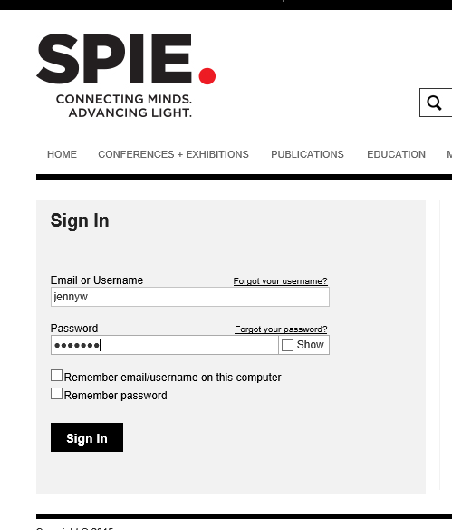

Step 1. Enter your paper’s title.

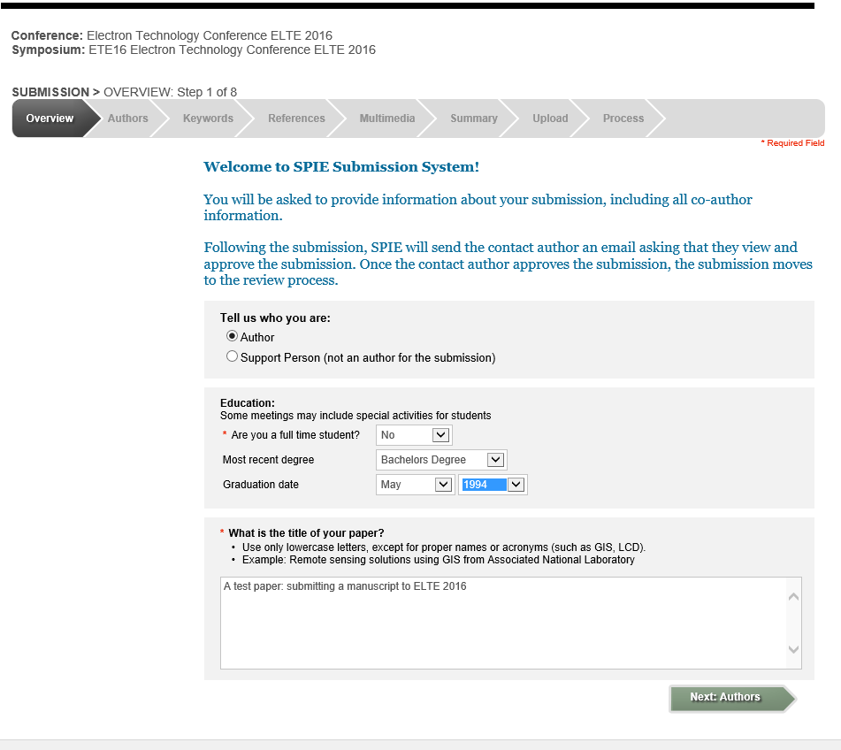
Step 2. Enter the contact author and coauthors. The contact author is the only author with access to the submission.

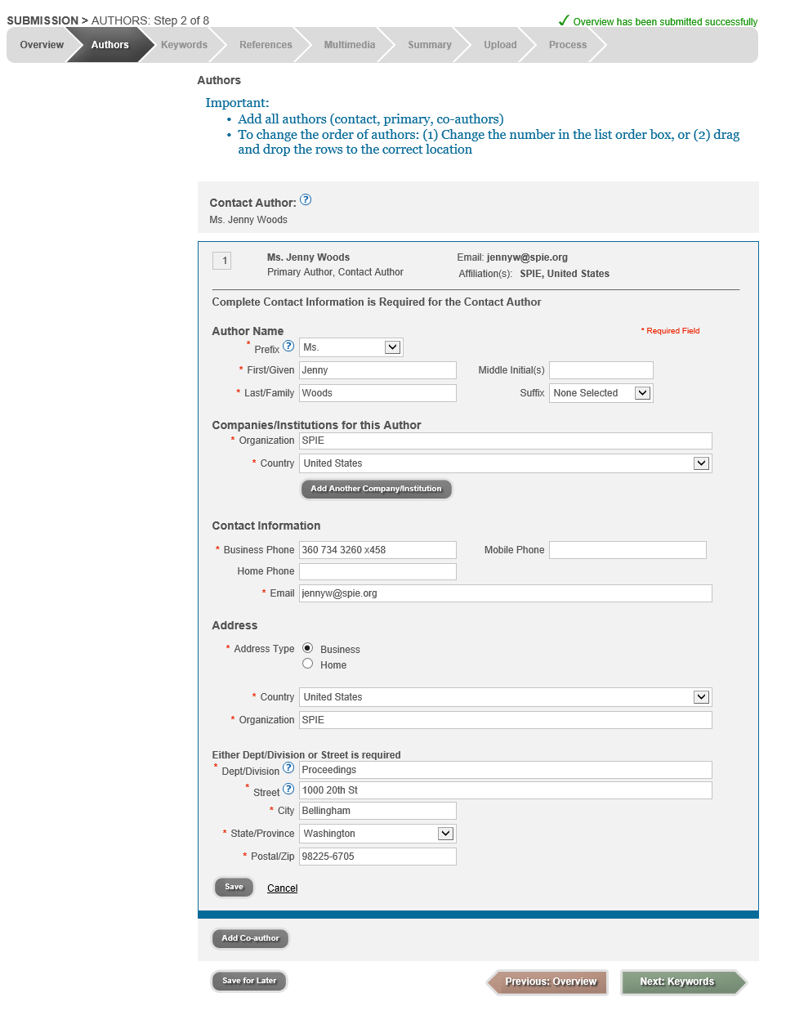
Step 3. Enter your key words.

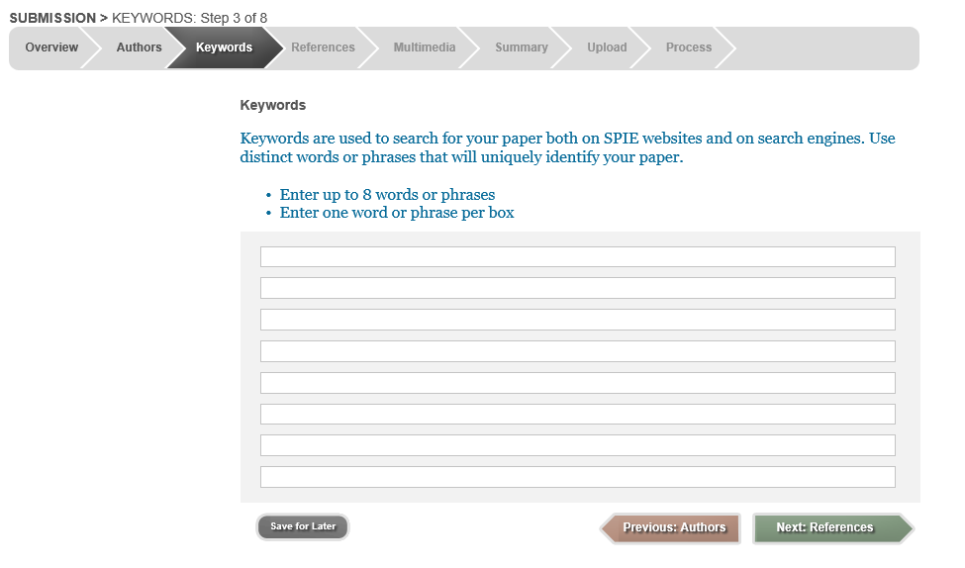
Step 4. Enter your references.
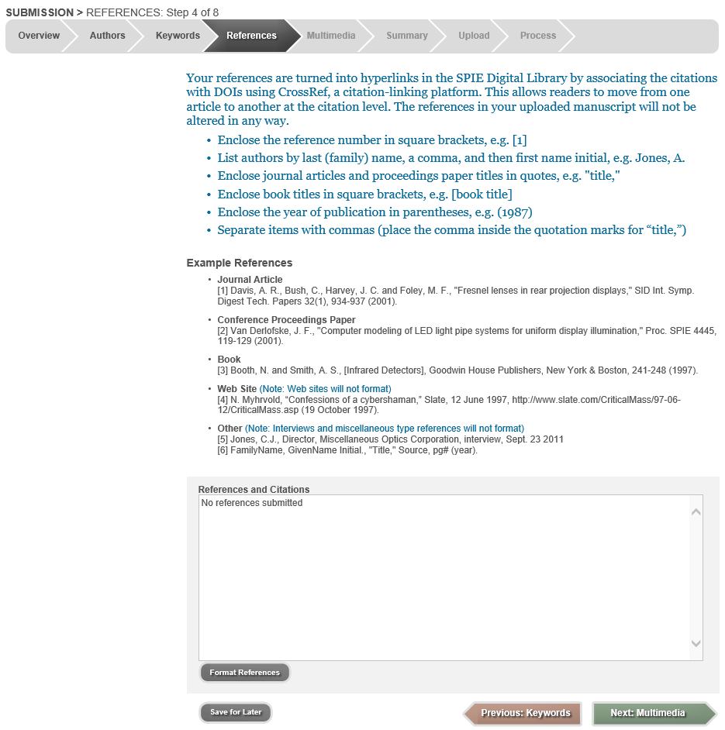
Step 5. Multimedia (optional)
*If you choose to submit multimedia files, your paper must contain a screenshot for each video or audio file. Include a descriptive caption beginning with ‘video 1, or audio 1, and include this link: http://dx.doi.org/doinumber.goes.here

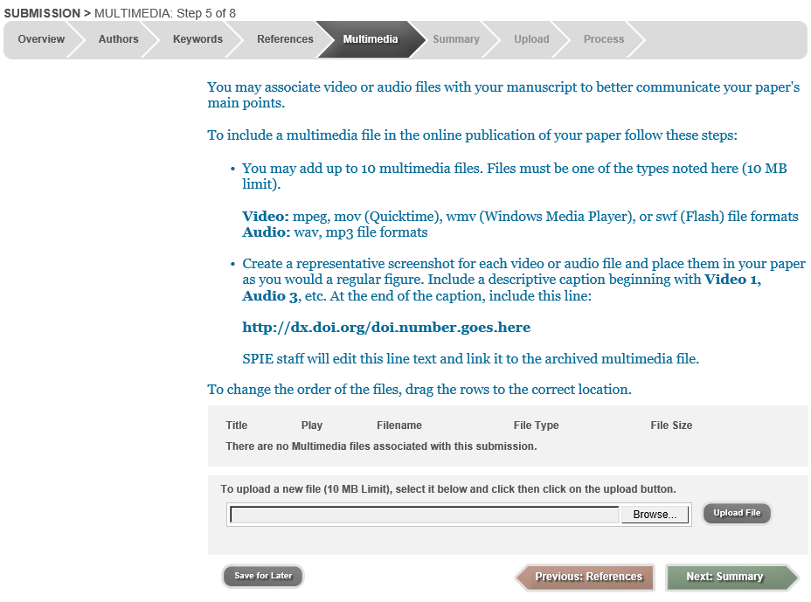

Step 6. Summary
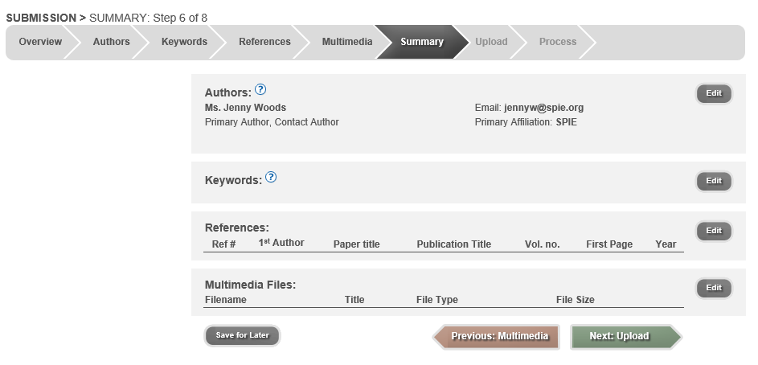
Step 7. Upload manuscript file
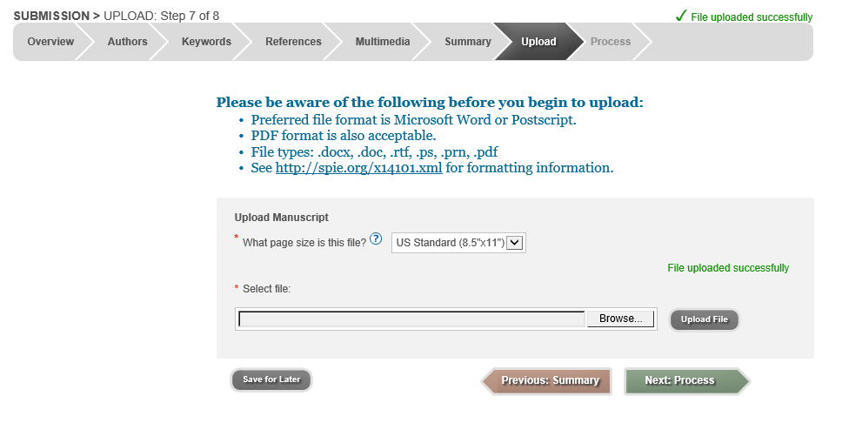
Step 8. Your paper is automatically assigned a tracking number.
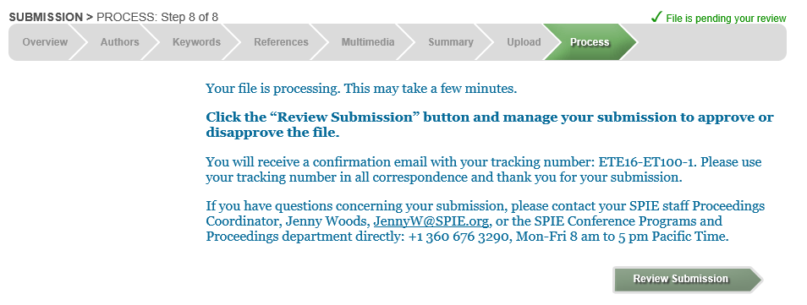

Return to your account at http://spie.org/myaccount to review the manuscript PDF and complete the submission. Also, submit your SPIE Transfer of Copyright form.

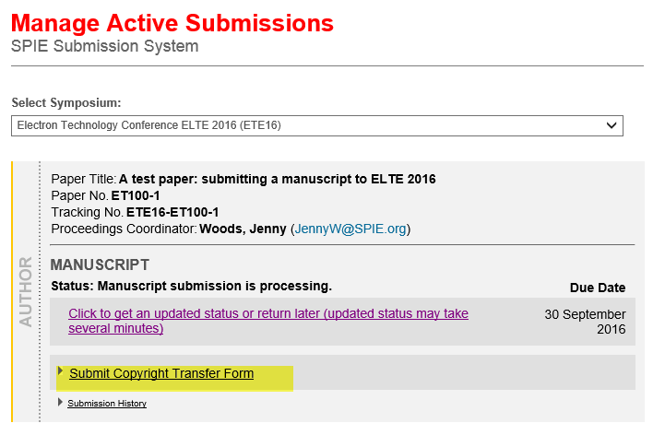
Review and approve submission. Return to your account at http://spie.org/myaccount to complete the submission. If the manuscript PDF is acceptable for publication, you must approve of it.
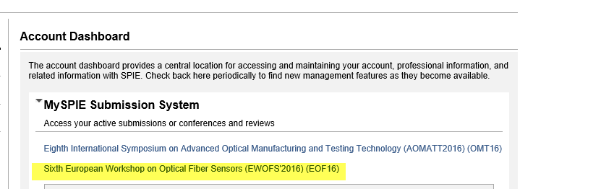

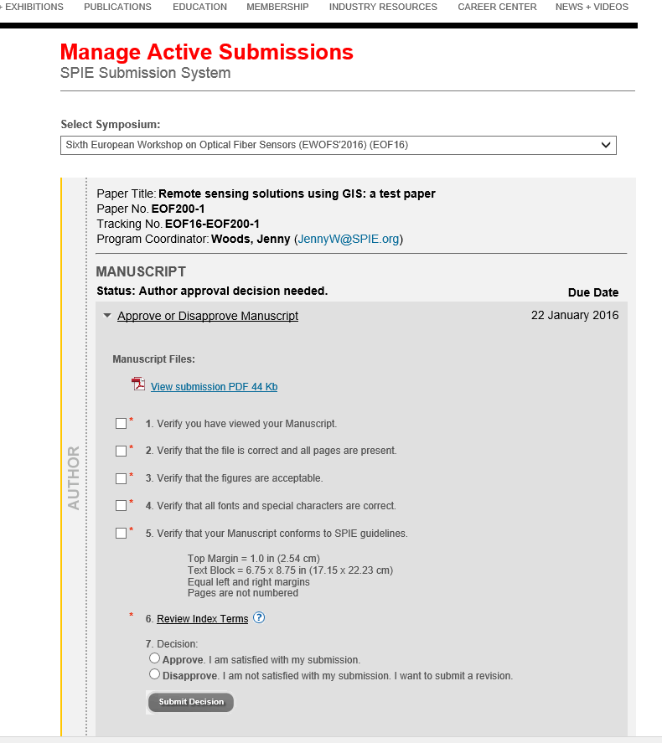

And Finally…Submit your SPIE Transfer of Copyright
A link should appear on the submission wizard for you to submit your copyright form. If you do not see the copyright link, then please download the form at http://spie.org/x14109.xml. Email your signed form to copyrights@spie.org.

